**Darren Pardo**

**Rutgers Data Science Bootcamp**

**Excel Homework**

**April 27, 2019**

**Kickstart My Chart Report**

**Abstract:**

Kickstarter is an internet funding platform for creative projects based out of Brooklyn, New York. The objective of this project is to organize and analyze the Kickstarter database of over four thousand past projects in order to uncover hidden trends in the successful projects.

**Introduction:**

Crowdfunding is the practice of funding a project or venture by usually raising small amounts of money from a large number of people via the internet. Kickstarter is a crowdfunding website similar to GoFundMe and INDIEGOGO, except that it is an all or nothing. In order to launch a Kickstarter project, you enter some basic information then start you campaign, determine your minimum funding goal and deadline. An import breakdown to understand is that each launch on Kickstarter falls into four possible states successful, failed, cancelled, or live upon the deadline.

Over two billion dollars have been raised using Kickstarter. However not every project has found success. Of the over 300,000 projects launched on Kickstarter, only a third have made it through the funding process with a positive outcome. The data analyzed falls into nine (9) categories and forty-one (41) sub-categories. Of the projects launched in the data set 53.11% were successful in reaching their funding goal.

**Preliminary Analysis**

The raw data started with 4,114 projects that were either successful, failed, cancelled, or is currently live at the deadline date of their campaign. I am primarily focused on the campaigns with a successful state so I combined all of the other projects states because I considered them all failing to meet the deadline parameter. This changes my data to 2,185 successful projects and 1,929 failed projects. The data analyzed is between 2009 and 2017, with a total pledged amount of over $46 million. The days of campaigning ranged from 3 to 90 days for a single project.

**Data Analysis**

Of the totaling projects launched the majority of the country’s location is the United States at 73.85%. In the total data set the United States contained more success at 40.13% than failure at 33.71%. On average successful projects had a higher number of backers than failed projects. Of the successful projects, 8.88% have a chance of reaching your goal and 91.12% chance of exceeding it. Therefore, being successful alone will most likely give you a surplus of funds. The category and sub-category with the most total projects are theater and plays. The theater category has more successful projects at 20.39% than failures at 13.47%. Similarly, the plays subcategory has more successful projects at 16.87% than failures at 9.04%. However, even though the theater has the most successful total project submissions it only has a 60% success rate in relation to the total projects submitted under the theater category.

State in relation to total projects.

|  |  |
| --- | --- |
| **State** | **% of Total Projects** |
| canceled | 8.48% |
| failed | 37.19% |
| live | 1.22% |
| successful | 53.11% |

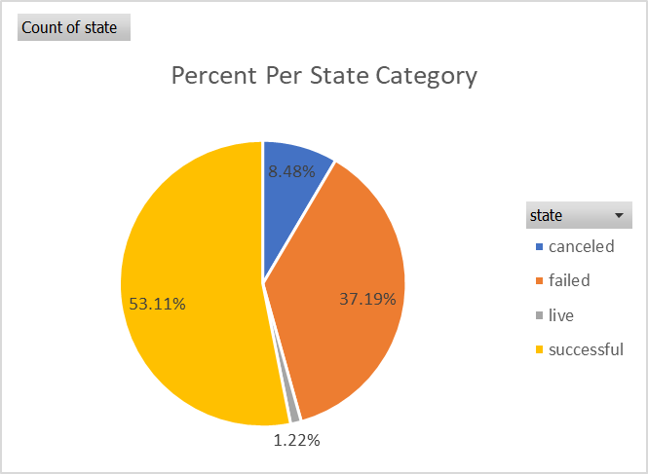

Successful project’s percent funded of the goal attained. This identifies that the majority of successful projects have surpassed their goals. Over 90% of the successful projects have reached over 100% of their goal.

Average number of backers per successful and failed projects.

Total projects in each category.

Success/failure rate in relation to the total projects submitted under each category.

**Conclusion**

Finally, there were a few limitations of this dataset that would hinder accurate predictions. Kickstarter was founded April 28, 2009 and therefore the practice, customer aptitude and familiarity with the site has changed since its beginning. The sample population given in the data has a date range between 2009 and 2017, therefore the ability to predict current trends may be skewed by the 8 years of past data. Due to the fact that the company was found in the US and the majority of project launches are out of the US this data is not a good representation of other country’s success and failure as a country or per category. For example, Luxemburg and Singapore have a 100% success rate for projects submitted from these countries however Luxemburg only submitted two projects and Singapore submitted a single project.

**References**

Rutgers Bootcamp Excel Homework Assignment - Kickstart My Chart

Kickstarter in Google search

<https://www.google.com/search?q=kickstarter&oq=kickstar&aqs=chrome.0.69i59j69i60l3j69i57j0.2469j0j7&sourceid=chrome&ie=UTF-8>

**Questions**

**Three conclusions we can make about Kickstarter campaigns given the provided data.**

* On average successful projects had a higher number of backers than failed projects.
* Of the successful projects, 8.88% have a chance of reaching your goal and 91.12% chance of exceeding it. Therefore, being successful alone will most likely give you a surplus of funds.
* Of the totaling projects launched the majority of the country’s location is the United States at 73.85%. In the total data set the United States contained more success at 40.13% than failure at 33.71%.

**Limitations of this dataset.**

* Kickstarter was founded April 28, 2009 and therefore the practice, customer aptitude and familiarity with the site has changed since its beginning. The sample population given in the data has a date range between 2009 and 2017, therefore the ability to predict current trends may be skewed by the 8 years of past data.
* Due to the fact that the company was found in the US and the majority of project launches are out of the US this data is not a good representation of other country’s success and failure as a country or per category. For example, Luxemburg and Singapore have a 100% success rate for projects submitted from these countries however Luxemburg only submitted two projects and Singapore submitted a single project.

**Potential Tables/Graphs**

* Table and pie graph of the percentage of each state in relation to the total of projects (e.g. "successful"(53.11%), "failed"(37.19%), "cancelled" (8.48%), and "live"(1.22%)).
* Table and clustered column graph of the percent funded of the successful projects. This will identify that the majority of successful projects have surpassed their goals.
* Table and clustered column graph of the average number of backers per successful and failed projects.
* Table and clustered column graph of the percentage of total projects per categories and then the percentage of total projects in each category (e.g. The theater has the most total project submissions at 1393 with a success rate 20.39% per the total projects. However, it only has a 60% success rate in relation to the total projects submitted under the theater category.).